Table of Contents

1.0 User Guide 2

1.1 Deploying application 2

1.2 Assessing Application User Interface 2

2.0 Screen Capture 3

2.1 Login Page 3

2.2 Information Page 3

# User Guide

## Deploying application

Prerequisite:

* Java 7 and JavaEE compatible application server, such as Glassfish.
* Refer following link to install Glassfish server 4.1.1 <https://glassfish.java.net/download.html>

Extract WebAppication.war from attached ATB User Login Test package, deploy the war file to Glassfish web application server with all default setting.

* Open a Command Line window, go to **glassfish4/bin** folder under Glassfish installation directory, run **asadmin start-domain** to start Glassfish server
* Load Glassfish server admin console, go to <http://localhost:4848>, if ask user/password for login, the default user and password are **admin**/**admin**
* Select **Applications** in left Tasks menu and click **Deploy** button in main panel
* Choose WebAppication.war that just extracted , keep all default setting and click **OK** button on right top corner
* Odata service is setup to using <https://localhost:8181> as default in url.properties , it should be same as hostname and port of application rul. The property file is located in **glassfish4\glassfish\domains\domain1\applications\WebApplication\WEB-INF\classes**
* go to <https://localhost:8181/WebApplication/Login.xhtml>

## Assessing Application User Interface

The following lists the steps for users to access the ‘Login’ application in web browser.

* Ensure the URL is correct.
  + <https://localhost:8181/WebApplication/Login.xhtml>
* Once the Login page is loaded, provide user name and password for login.
  + The User name rule:
    - Must be 3 -10 characters
    - Must be an existing user in system
  + The password rule:
    - 8-12 characters long
    - At least one capital, lower case, and one of the symbols: %#*&!@
    - Cannot have more than 3 letters together
  + Validation check mark:
    - Checked: message shows in Login Page if client validation fails
    - Unchecked: message shows in Info Page if server validation fails
  + Three built-in userName/Password, you could update or add more users in data source file which located on :
    - Tom / ZaS5#43d378
    - Obama / ZsS5&43378
    - Trudeau/ ZU5@433e78

# Screen Capture

## Login Page

Initial Login Page with validation enabled

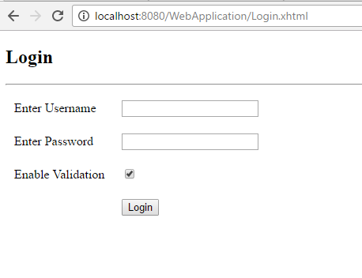

User name and Password validation fails with validation enabled

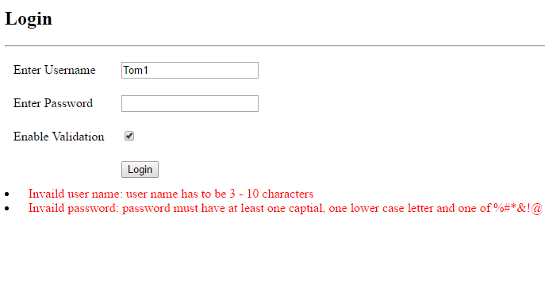

User verification fails when validation enabled

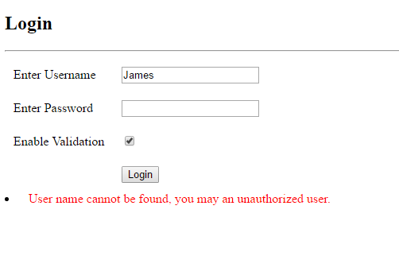

Password verification fails when validation enabled

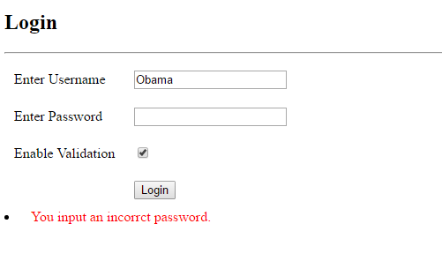

## Information Page

User name and Password validation fails with validation disabled in client side

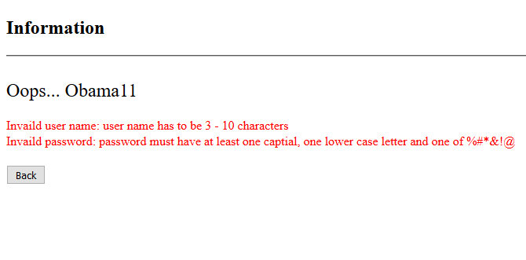

User verification fails with validation disabled in client side

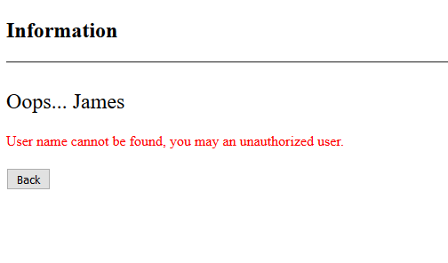

Password verification fails with validation disabled in client side

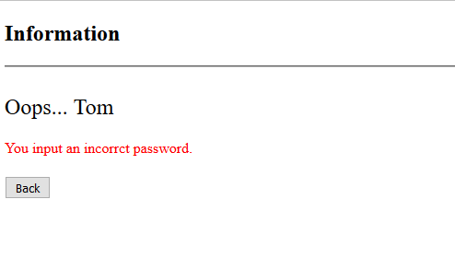

User passed verification

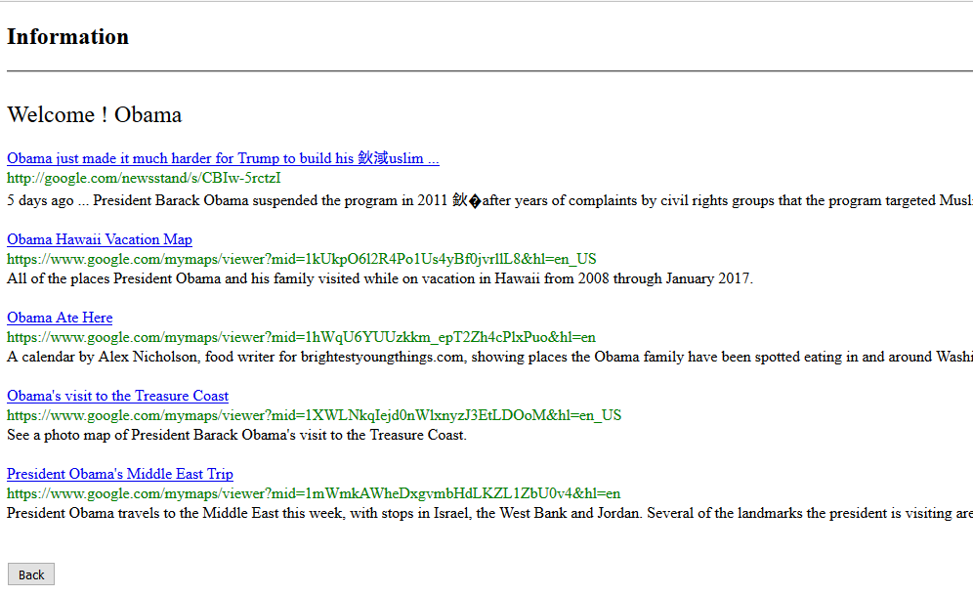

** The search results from Custom Search Engine (free edition) are different with Google Site Search (paid edition) which is using on Google site.